

**SAFE SUBMARINE BATTLE**

**BTech/II Year CSE/IV Semester**

**19CSE214/THEORY OF COMPUTATION**

|  |  |
| --- | --- |
| Rollno | Name |
| CB.EN.U4CSE21062 | **Tangudu Harsha Vardhan** |
| CB.EN.U4CSE21034 | **Manthini Meher Vardhan** |
| CB.EN.U4CSE21040 | **Nerella Geetha Krishna** |
| CB.EN.U4CSE21039 | **N.G.R.Krishna Reddy** |
| CB.EN.U4CSE21029 | **Katta Rahul krishna** |

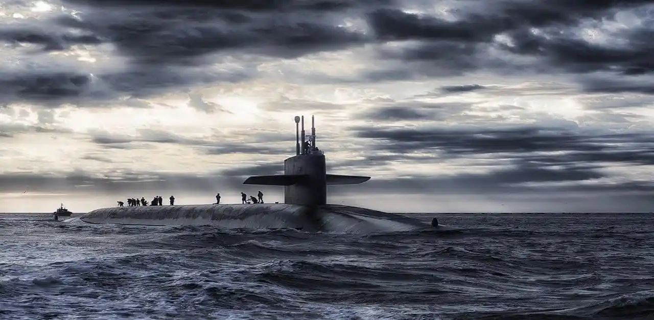

**PROBLEM STATEMENT**:

In this real-time war scenario, our objective is to analyse the outcome of a **submarine's** journey in two different conditions. The first condition entails the submarine reaching the base safely, without engaging in a battle. The second condition involves the submarine reaching the base safely, but only after having participated in a battle.

**INTRODUCTION:**

Before a submarine enters the water, a detailed procedure needs to be initiated. The missile rack must be loaded with the proper equipment, and the fuel level in the tank must be ensured. The most essential condition is to conduct a surface check of the water. The ballet is then filled for stability and buoyancy and loaded into the submarine. An equipment check is performed before turning on the propulsion system and finally activating the engine. Once the submarine is in the water, route assignment takes place for the battle, with the goal of achieving four states:

1. Lost state: Reaching the post-dive state after moving out of the enemy radar range.

2. Submarine reconnaissance: Gathering information or intelligence about the target using submarines.

3. Practicing defensive manoeuvres: Crucial actions to ensure safety and protection.

4. Sonar locking mode: Actively tracking or engaging a specific target using sonar capabilities.

Each mode ultimately leads to the post-dive state. After reaching this state, the propeller state is turned off, followed by the engine state. Once the battle is over, an equipment check is conducted, ballast is cleared, and the submarine resurfaces. The base is reached by surfacing, and fuel levels are checked. Finally, a missile count analysis is performed to assess the battle's outcome.

**GOAL OF THE PROJECT:**

Our goal is to thoroughly examine both scenarios, considering factors such as missile status, equipment effectiveness, and potential threats encountered during the battle. By conducting a comprehensive analysis, we aim to gain insights into the effectiveness of different approaches in ensuring the submarine's safe arrival at the base, regardless of whether combat engagement took place.

**PUSHDOWN AUTOMATA**

**INPUT SYMBOLS:**

Mc-> Count of the missile

Fc -> Fuel checking

Es -> Dive, Surface check System ON

Bf -> Ballast Tanks Filled

Ec -> Equipment Checking

Pr -> Propulsion System ON

Ra -> Submarine Route Assigned

Sr-> Submarine reconnaissance mode

Sr0-> Back to Autonomous mode after reconnaissance

Psl -> Sonar Locking mode

Psl0 -> Back to Autonomous mode after sonar locking

Def -> Practicing Defensive Maneuvers

Def0-> Back to Autonomous mode after practicing defensive maneuvers

L -> Submarine Landing Procedures Initiated

Pr0 -> Propulsion System OFF

Ec0 -> Equipment Checking

Bf0 -> Ballast Tanks Drained

Es0 -> Dive, Surface check System OFF

Fc0 -> New fuel count

Mc0->New missile count equal to old missile count

Mc1->New missile count less than old missile count

**LANGUAGE:**

L={(Mc.Fc.Es.Bf.Ec.Pr). C .(Pr0.Ec0.Bf0.Es0.Fc0.Mc0), C ∈ [R.(Q + (Aa.Dd.L + Aa.Ll.D + Ll.Dd.A + Aa.D + Aa.L + Dd.A + Dd.L + Ll.A + Ll.D + A + D + L).O).r}

**GRAMMAR:**

S-> M A M’

A->F B F’

B-> E C E’

C-> B D B’

D->W P W’

P->P G P’

G->R K O R’/ λ

K-> Q / Mm Nn L / MmLlN / LlNnM / MmN /MmL / Nnm / MmL / Nnd/M /

N / L

**STATES:**

q0 -> idle state

q1-> Missile counting state

q2-> fuel checked state

q3-> pre dive, surface check system

q4-> ballast tank filled

q5-> equipment checking

q6-> engine ON

q7-> engine OFF

q8-> equipment check

q9-> ballast drained

q11-> surface check system OFF

q12-> comparing fuel with before fuel DATA

q13-> new missile count equal to updated missile count

q14-> reached safely without Battle

q15-> new missile count is less than updated missile count

q16-> reached safely after battle

q17-> Submarine route assigned

q18-> unknown territory

q19-> Submarine reconnaissance

q20-> sonar locking mode

q21-> practising defence maneuver

q22-> Landing procedure initiated

q23-> post dive

**THE FINAL PDA DIAGRAM:**

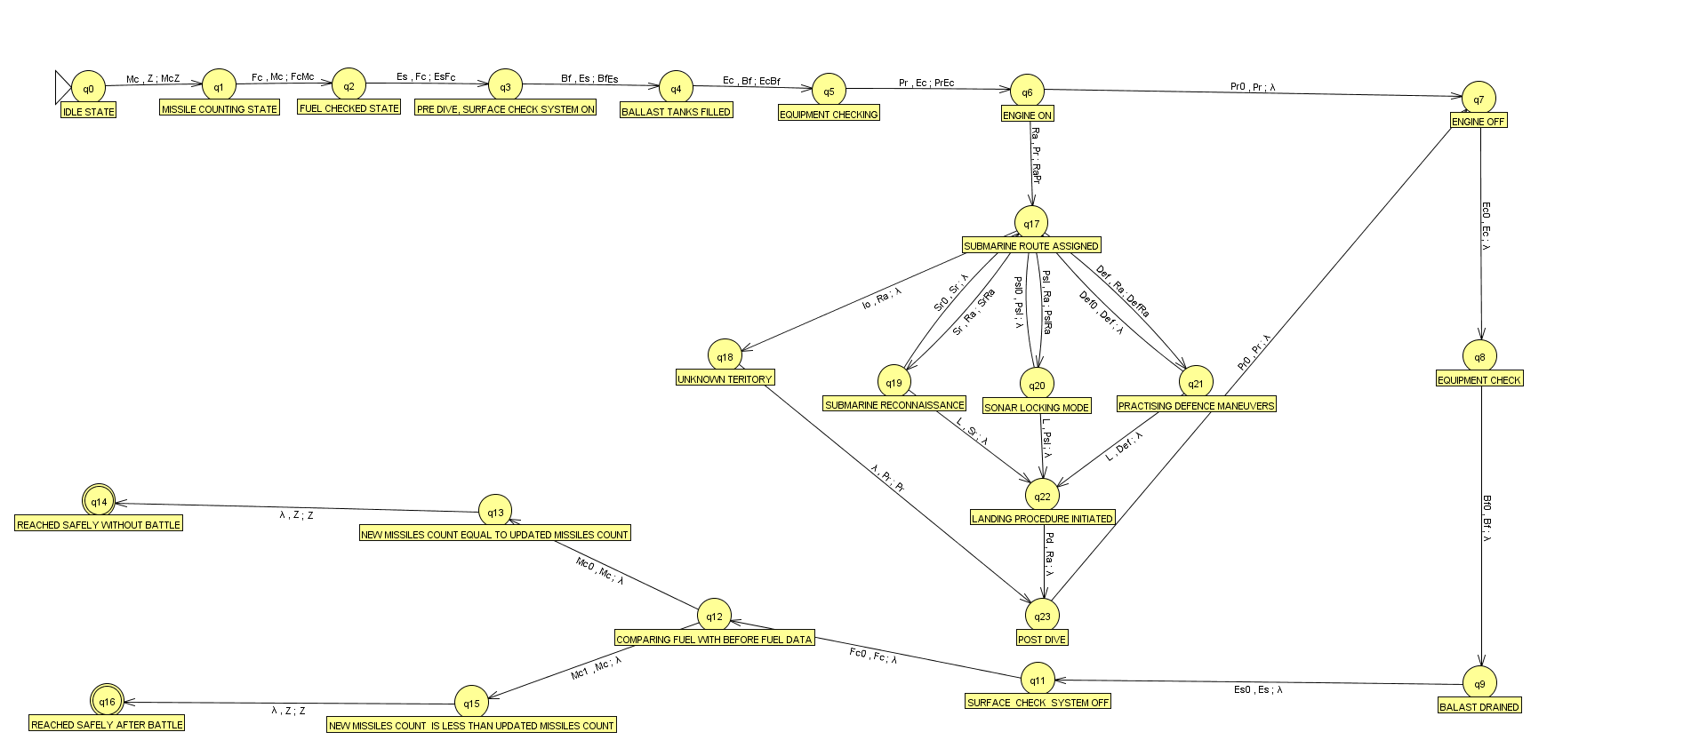

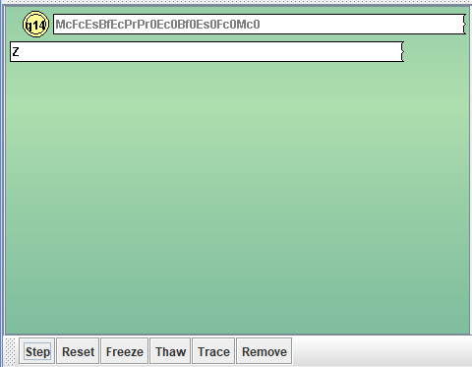

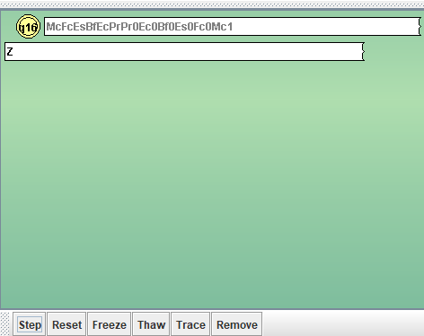

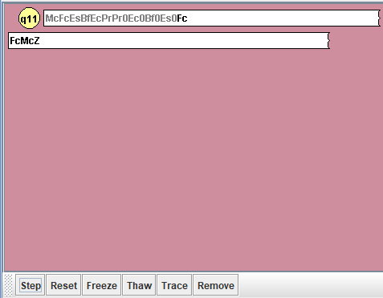

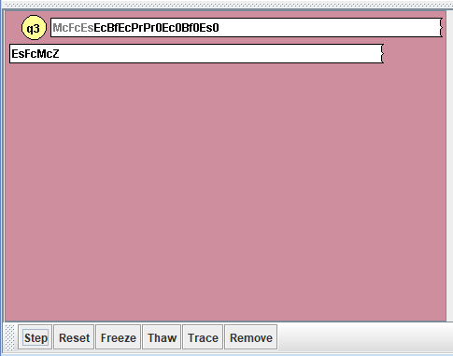

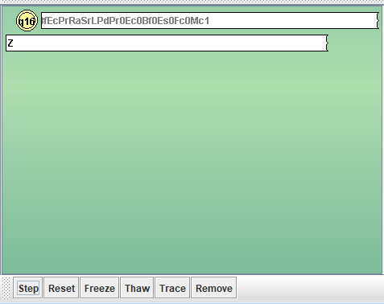

**TURING MACHINE**

**Turing Machine Conversion:**

In order to convert the pushdown automaton (PDA) scenario into a Turing machine (TM) scenario, we need to modify the input symbols, stack operations, and transitions accordingly. Since a Turing machine has an infinite tape instead of a stack, we'll replace the stack operations with tape movements and modifications.

**Input Symbols:**

M-> Count of the missile

F -> Fuel checking

S-> Dive, Surface check System ON

B -> Ballast Tanks Filled

E -> Equipment Checking

P-> Propulsion System ON

R -> Submarine Route Assigned

Sr-> Submarine reconnaissance mode

Sr0-> Back to Autonomous mode after reconnaissance

Psl -> Sonar Locking mode

Psl0 -> Back to Autonomous mode after sonar locking

Def -> Practicing Defensive Maneuvers

Def0-> Back to Autonomous mode after practicing defensive maneuvers

O -> Submarine Landing Procedures Initiated

p -> Propulsion System OFF

e -> Equipment Checking

b-> Ballast Tanks Drained

s -> Dive, Surface check System OFF

f -> New fuel count

m->New missile count equal to old missile count

m->New missile count less than old missile count

z -> lambda

**FINAL DIAGRAM:**

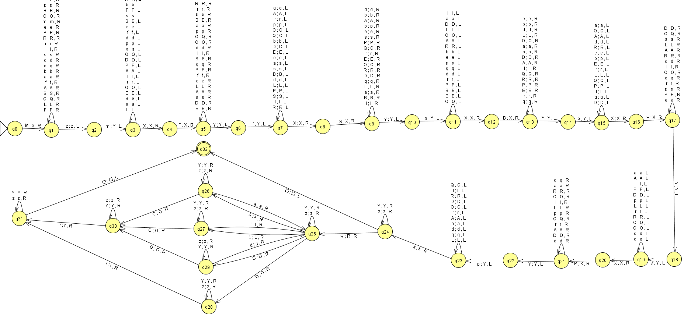

**VALID STRINGS:**

MFSBEPpebsfmz

MFSBEPRLlAOrpebsfmz

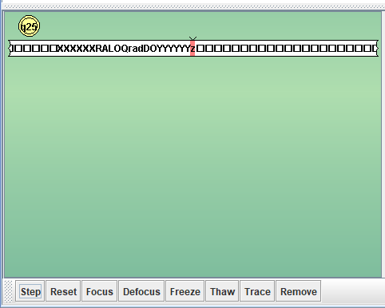

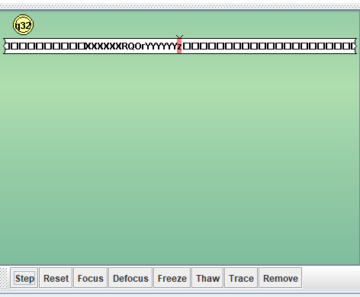

**INVALID STRINGS:**

MFSBEPRLlAQrpebsfmz

MFSBEPRLlADrpebsfmz

MFSBEPRLlQrpebsfmz

**Modified Transitions:**

Since Turing machines have a different transition function, we'll need to modify the transitions based on the original PDA transitions. Each transition will be defined by the current state, current tape symbol, and the next state, tape symbol, and tape movement.

**CONTRIBUTION:**

|  |  |  |
| --- | --- | --- |
| Rollno | Name | CONTRIBUTION |
| CB.EN.U4CSE21062 | **Tangudu Harsha Vardhan** | DESIGN OF THE PUSH DOWN AUTOMATA, PUSH DOWN AUTOMATA JFLAP IMPLEMENTATION,DOCUMENTATION OF TEST CASES |
| CB.EN.U4CSE21034 | **Manthini Meher Vardhan** | ANALYSIS, TURING MACHINE DESIGN AND DOCUMENTATION. TURING MACHINE JFLAP IMPLEMENTATION . |
| CB.EN.U4CSE21040 | **Nerella Geetha Krishna** | TURING MACHINE JFLAP IMPLEMENTATION, TESTING AND DOCUMENTATION |
| CB.EN.U4CSE21039 | **N.G.R.Krishna Reddy** | BOUNDARY CASES, TEST CASE FORMULATION AND VERIFYING FOR PDA, TAND DOCUMENTATION |
| CB.EN.U4CSE21029 | **Katta Rahul krishna** | PUSH DOWN AUTOMATA JFLAP IMPLEMENTATION AND DOCUMENTATION. |